

Individual Assessment Coversheet

To be attached to the front of the assessment.

**Campus: Midrand __________________________________________________________________________**

**Faculty: Information Technology __________________________________________________________________________**

**Module Code: ITLSA1 __________________________________________________________________________**

**Group: 4_________________________________________________________________________**

**Lecturer’s Name: Dr Bouwer __________________________________________________________________________**

**Student Full Name: Asimdumise Zwane __________________________________________________________________________**

**Student Number: EDUV4935855 __________________________________________________________________________**

|  |  |  |
| --- | --- | --- |
| **Indicate** | **Yes** | **No** |
| Plagiarism report attached |  |  |

**Declaration:**

I declare that this assessment is my own original work except for source material explicitly acknowledged. I also declare that this assessment or any other of my original work related to it has not been previously, or is not being simultaneously, submitted for this or any other course. I am aware of the AI policy and acknowledge that I have not used any AI technology to generate or manipulate data, other than as permitted by the assessment instructions. I also declare that I am aware of the Institution’s policy and regulations on honesty in academic work as set out in the Conditions of Enrolment, and of the disciplinary guidelines applicable to breaches of such policy and regulations.

|  |  |
| --- | --- |
| **Signature A.N Zwane** | **Date June 22, 2024** |

**Lecturer’s Comments:**

|  |
| --- |
|  |

|  |  |  |
| --- | --- | --- |
| **Marks Awarded:** |  | **%** |
|  |  |  |
| **Signature** | **Date** | |

Eduvos (Pty) Ltd. (formerly Pearson Institute of Higher Education) is registered with the Department of Higher Education and Training as a private higher education institution under the Higher Education Act, 101, of 1997. Registration Certificate number: 2001/HE07/008

Table of Contents

Table of Figures 2

Question 1 3

Question 2 4

Question 3 11

Bibliography 16

# Table of Figures

Figure 1 VM with student name 5

Figure 2 Installing Ubuntu Linux 6

Figure 3 Install setup 6

Figure 4 2GB of RAM 7

Figure 5 20GB of Disk space 7

Figure 6 New user with sudo privileges 8

Figure 7 Update of system packages 9

Figure 8 Launching Chrome 9

Figure 9 Installing Chrome 10

Figure 10 Displaying hidden files 10

Figure 11 Basic Firewall 11

Figure 12 Installation of GNOME desktop 12

Figure 13 GNOME desktop installation process 12

Figure 14 Installing GNOME shell extensions 13

Figure 15 Installing Dash to Panel 13

Figure 16 Installing Clipboard indicator 14

Figure 17 Appearance modification 15

Figure 18 New screensaver 16

Figure 19 New font size 16

# Question 1

Ubuntu and Kali Linux are popular Linux distributions that have different uses in thr computer industry. Ubuntu is based on a strong Debian foundation and the GNOME desktop environment. It strikes a balance between usability and the power of Linux. Ubuntu provides suitability for desktops, cloud environments, and servers. The Offensive Security Ltd-maintained Kali Linux, on the other hand, is designed especially for security auditing and penetration testing. (Editor, 2024)

Kali and Ubuntu are based on the Debian Linux distribution. Since its original release in 1993, Debian has been one of the most popular and oldest Linux versions available. A wide range of Linux distributions, from user-friendly general operating systems like Ubuntu, to specialized versions with specialized tools like Kali Linux, use Debian as their foundation. (Hodgson, 2024)

Ubuntu has quiet a few pros. It has a user-friendly interface that is suitable for beginners and experienced users. The GNOME desktop environment offers a seamless and modern user experience. Users can readily access support through manuals, forums, and some online resources due to it’s vibrant community. The APT package management system in ubuntu provides access to a wide store of software. It has strong security features. Users can customize Ubuntu to their own taste. It is compatible with a lot of devices. It has open-source software and it is very efficient.

Although there is a number of pros, there are a few cons as well. The cons list includes, hardware compatibility, technical support, and software availability. Updates and installations can occasionally disrupt system functionality. It may have performance issues. The process of customization is time-consuming. Using different package formats can lead to confusion and dependence concerns. Some enterprise contexts may find Ubuntu lacking in certain capabilities and integrations required for large-scale corporate use. (Qasim, 2023)

Kali Linux comes pre-installed with a comprehensive set of security tools. Kali Linux is regularly upgraded. There are a lot of documentations and tutorials that can help beginners. It is highly customizable. It can be run from a USB. Students can learn in a real-world setting of cybersecurity. There are different installation methods. It is open source. It comes with pre-configured security settings and configurations. Kali Linux is adaptable to a variety of gadgets.

Kali Linux also has cons that include security risks, hardware compatibility, and limited software repository. The functionality and user interface for beginners may be intimidatingly complex. It requires very powerful hardware in order to run smoothly. The frequent updates can be disruptive. There may be privacy concerns because Kali Linux automatically collects and reports statistics regarding usage. Kali Linux is primarily designed for security testing rather than productivity tasks. It takes a significant amount of time to learn how to use Kali Linux properly. (Fernando, 2024)

After evaluating the pros and cons of both Ubuntu and Kali Linux I realized that it is critical to choose a Linux distribution that is adaptable, dependable, and well supported, therefore I would recommend that TechCorp chooses to use Kali Linux. It was specifically designed for security professionals, penetration testers, and hackers that hack ethically. Although Ubuntu is a better option for most web development needs. Kali Linux is the better choice due to its focus on network security and penetration testing. Right out of the box, it has all the tools required for security audits and penetration tests. It is intended for security experts who require an atmosphere created especially for security-related duties just like the employees of TechCorp. (Williams, 2018)

# Question 2

2.1. In order for me to create a new VM and name it using my student name I press on “new”.

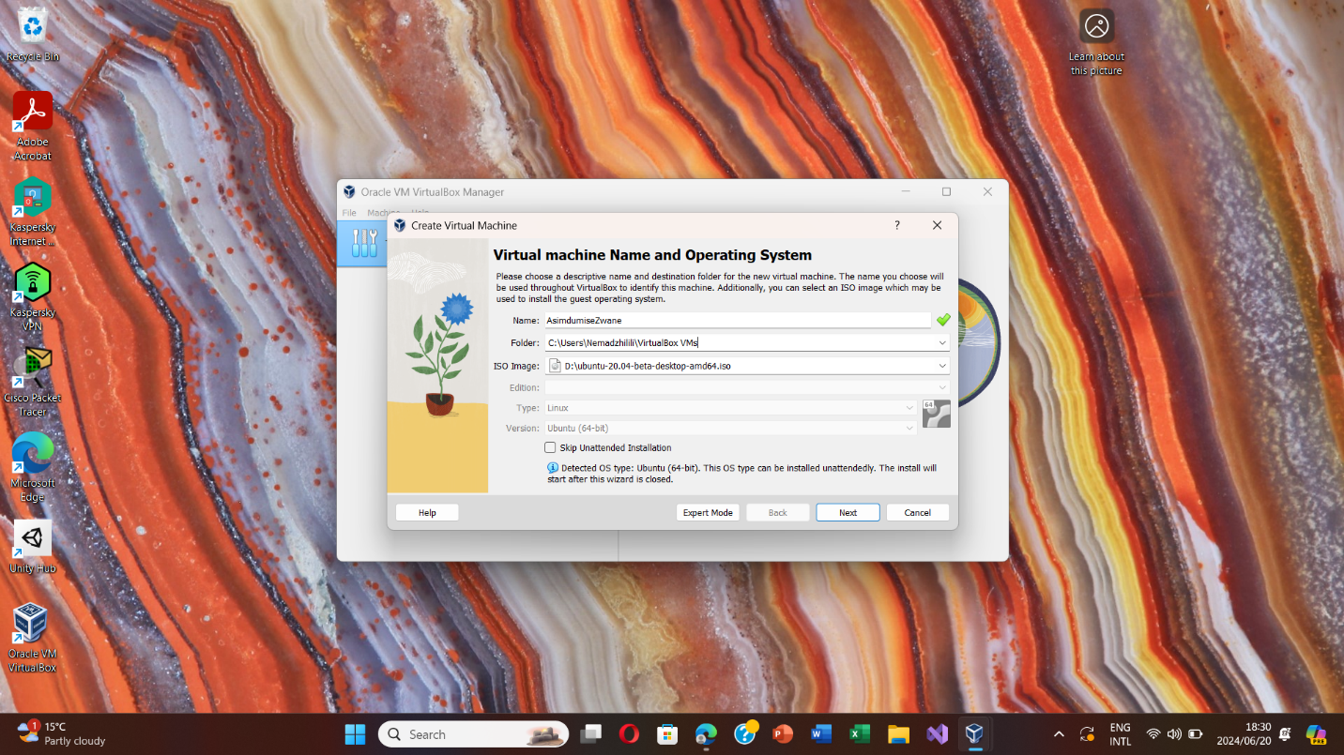

Figure 1 VM with student name

I then proceed to install the latest version of Ubuntu Linux as the guest OS

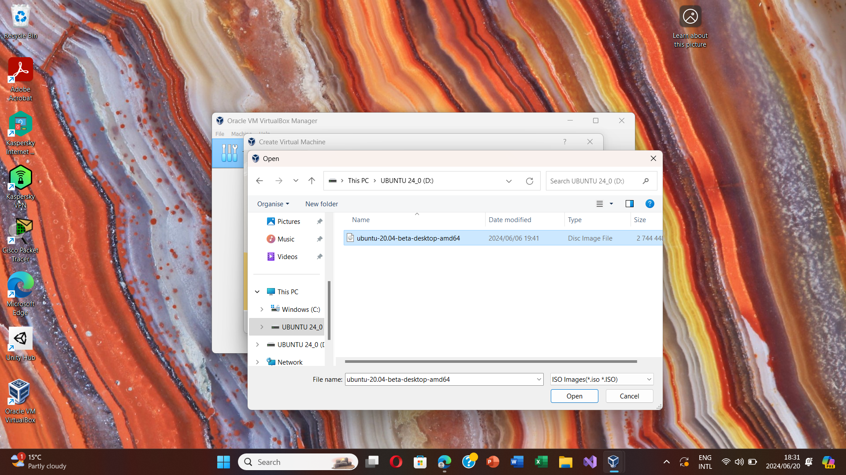

Figure 2 Installing Ubuntu Linux

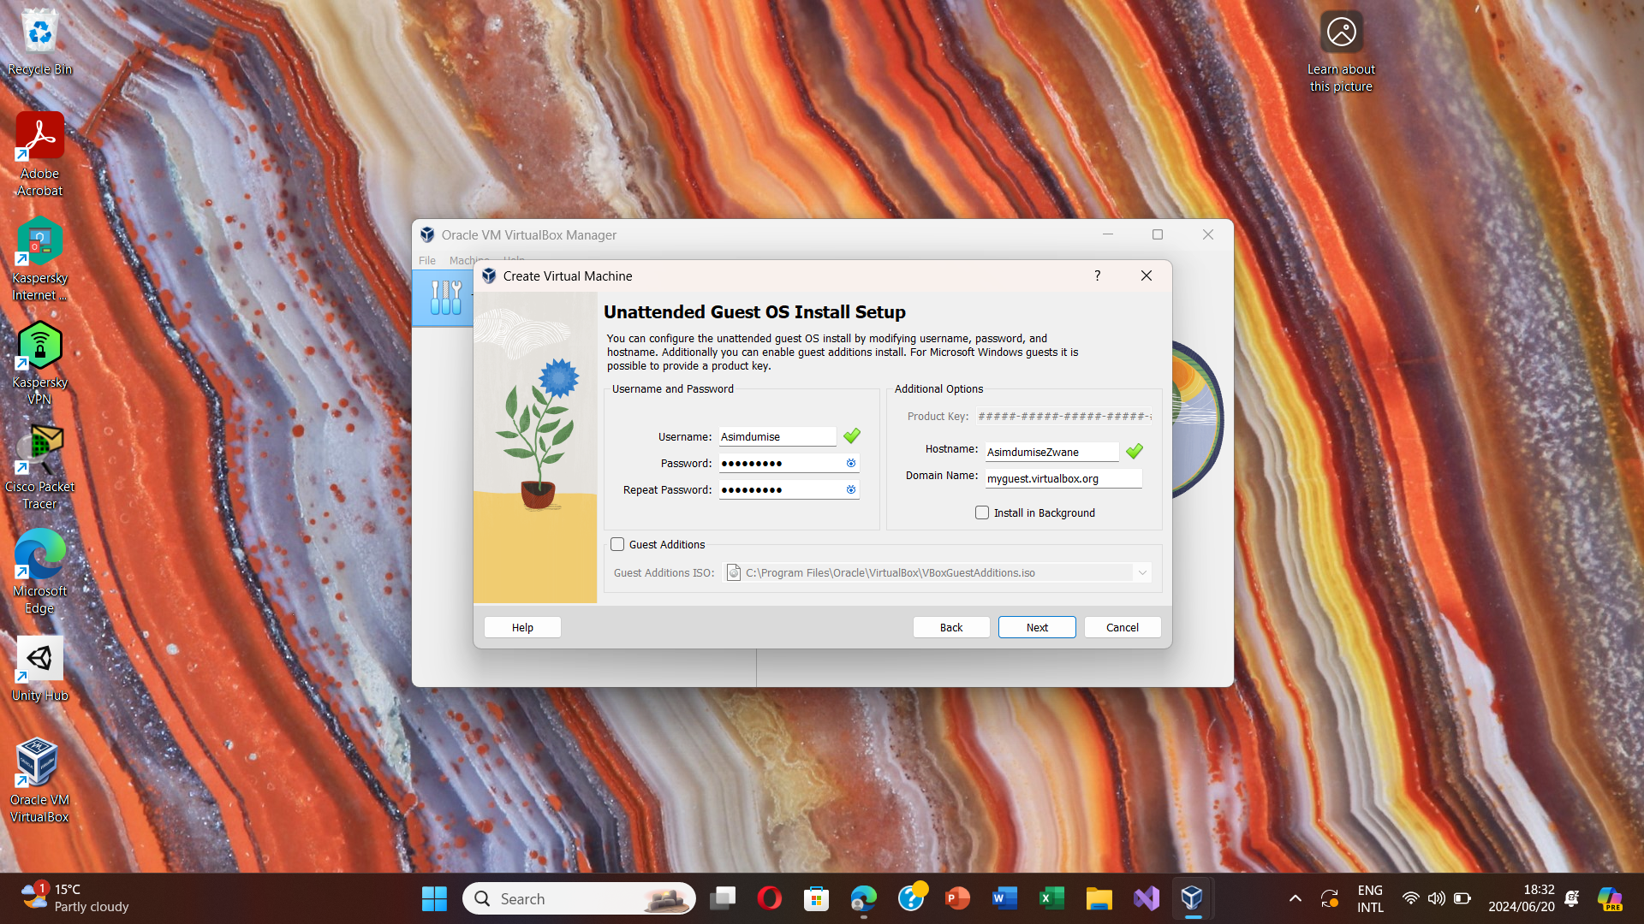

Figure 3 Install setup

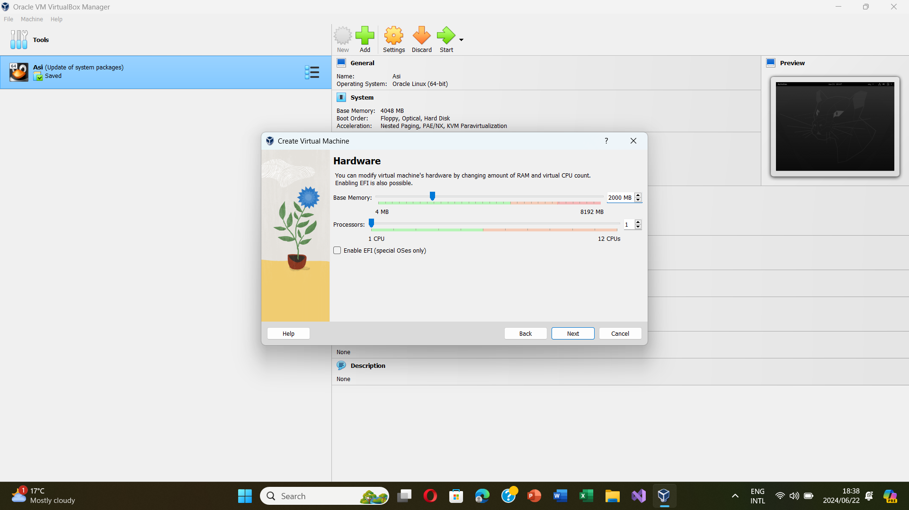

Figure 4 2GB of RAM

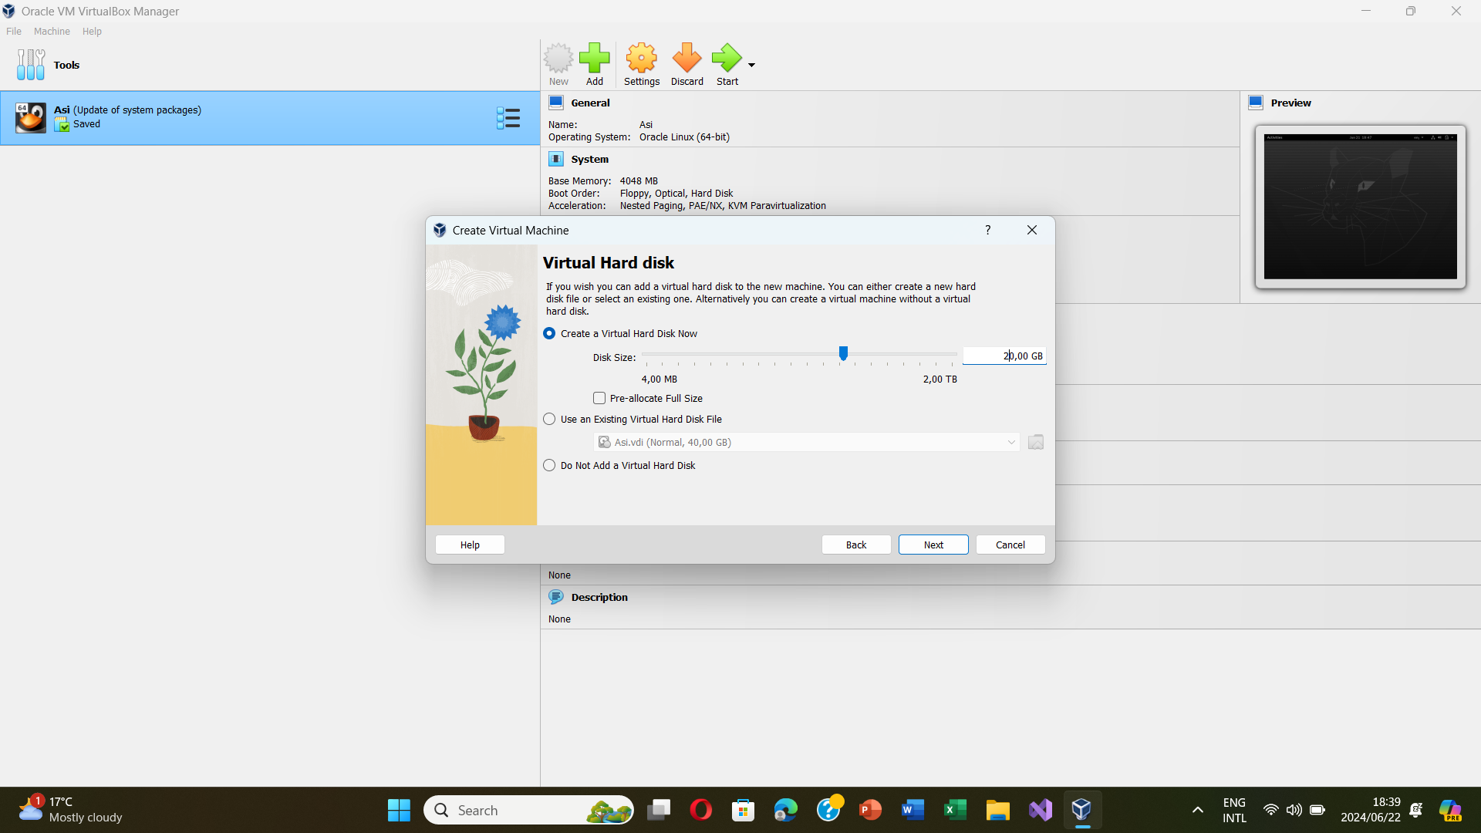

Figure 5 20GB of Disk space

2.2. I therefore created a new user with my name as the username, granting myself sudo privileges and I set a secure password. (Zandbergen, 2022)

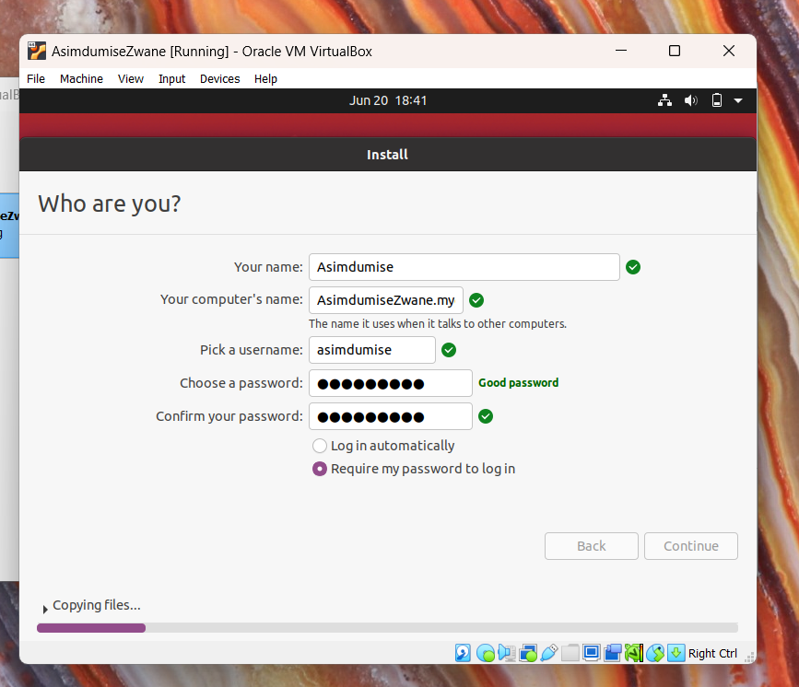

Figure 6 New user with sudo privileges

2.3. I updated the package index with: **sudo apt-get update**

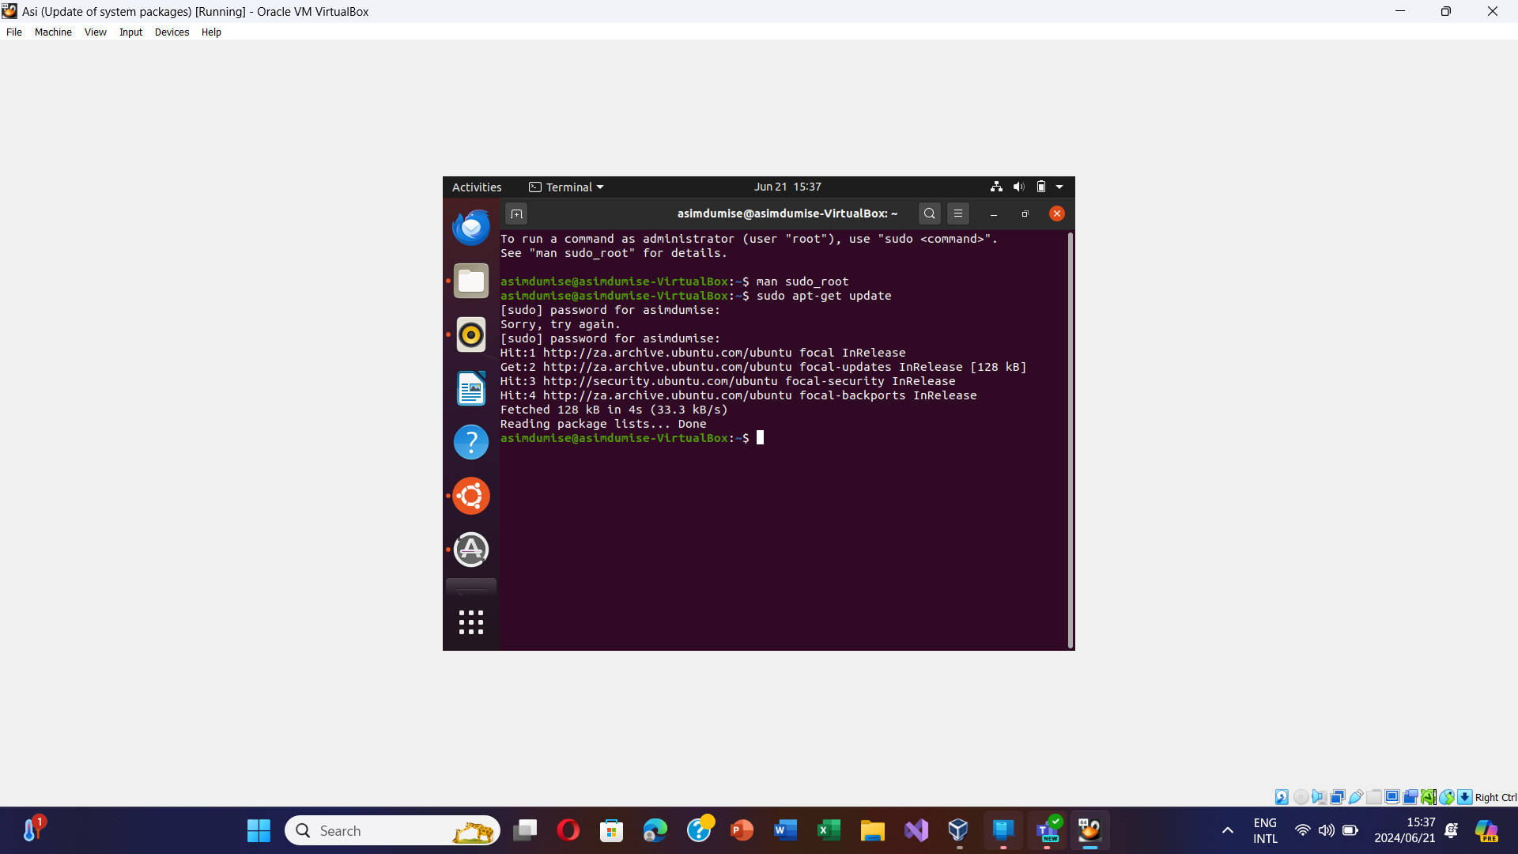

Figure 7 Update of system packages

Before launching chrome I ran this command: **sudo apt install wget**. I then ran this command: **sudo dpkg -I google-chrome-stable_current_amd64.deb**

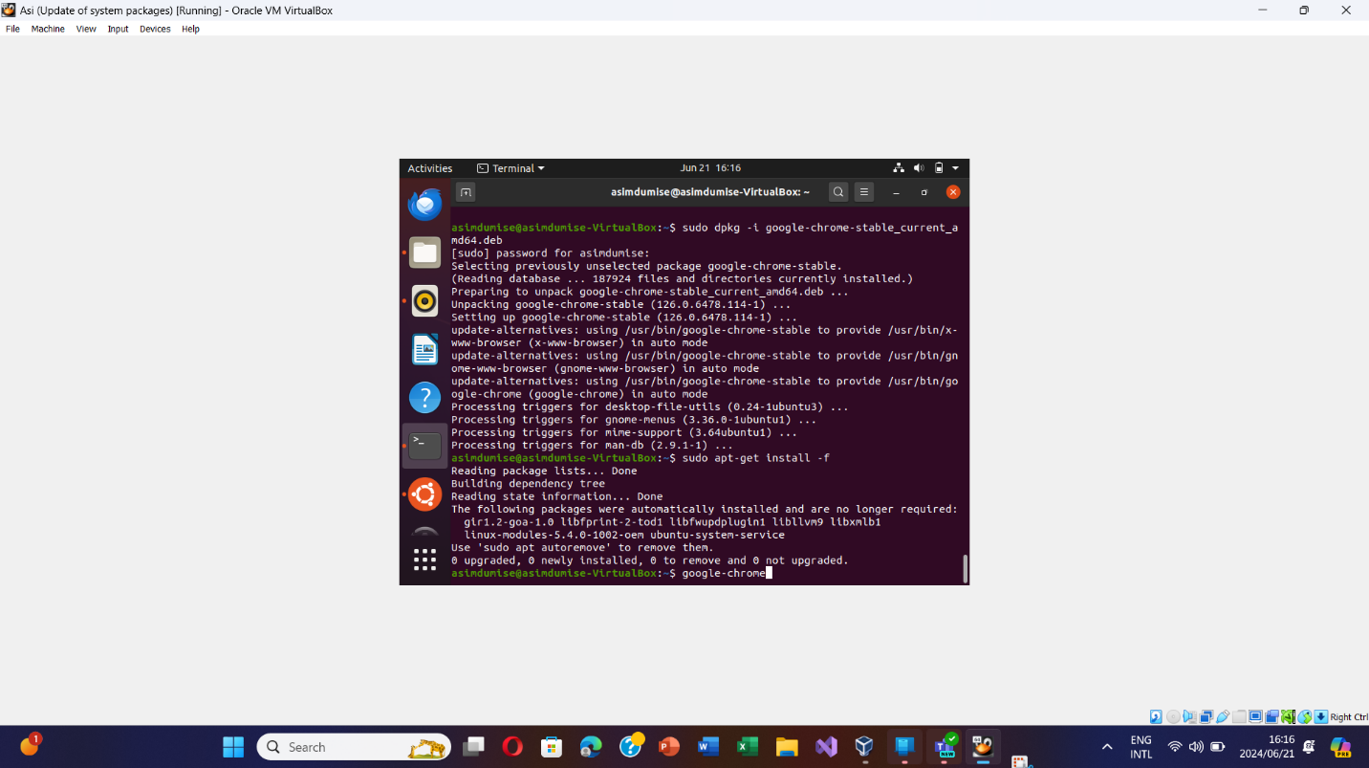

Figure 8 Launching Chrome

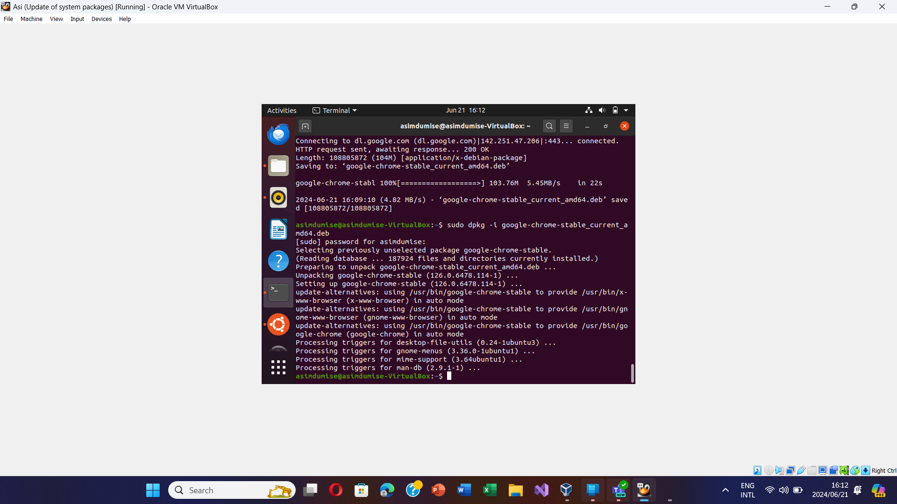

Figure 9 Installing Chrome

After installing chrome, I configure the system to display hidden files.

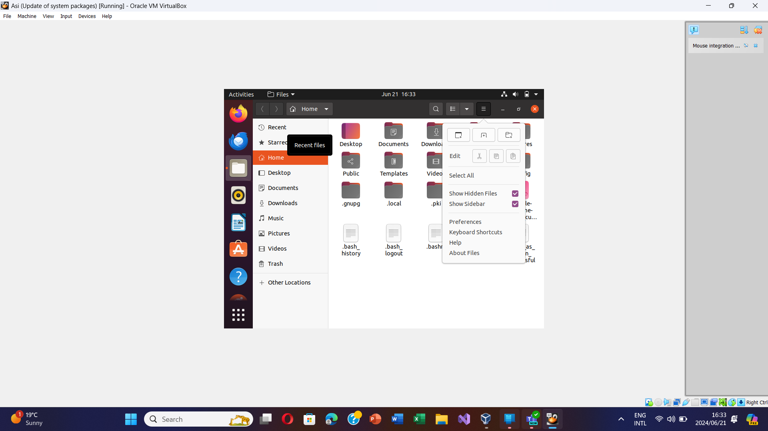

Figure 10 Displaying hidden files

I used the command to create a text file: **touch ~/Documents/work_document.txt**. I then used: **cat ~/Documents/work_document.txt** to view the text file.

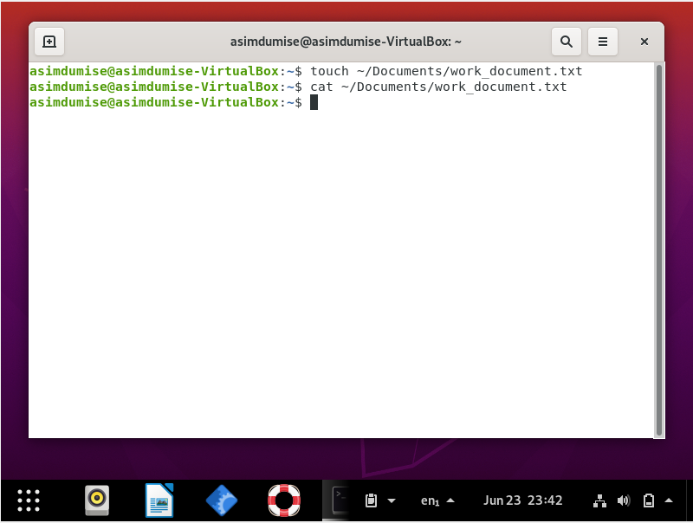

2.4. Figure 11 displays how I setup and configured a basic firewall.

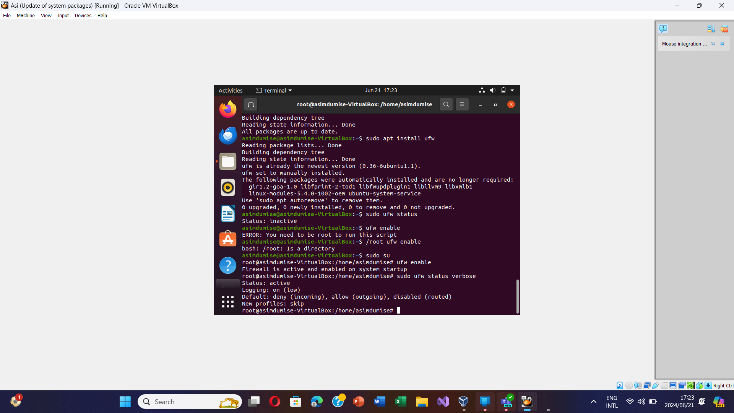

Figure 11 Basic Firewall

# Question 3

3.1. I installed the Ubuntu GNOME desktop using the commands in figure 12 and figure 13.

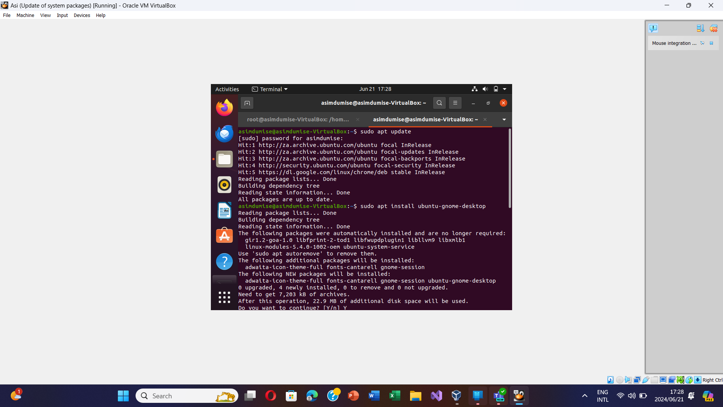

Figure 12 Installation of GNOME desktop

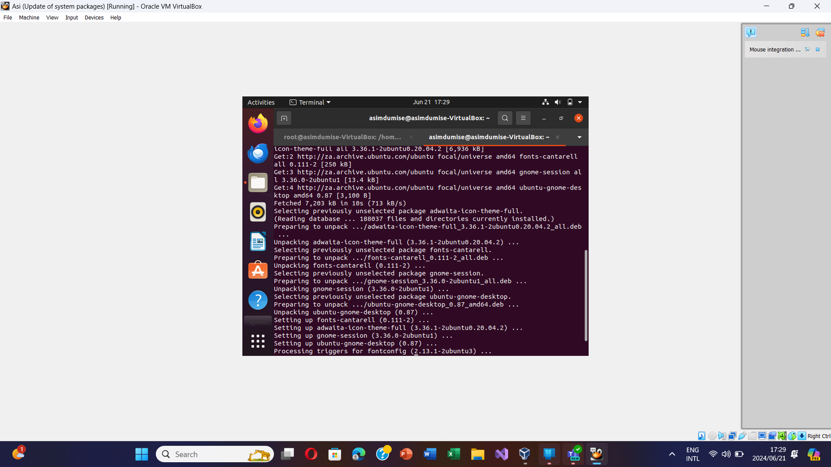

Figure 13 GNOME desktop installation process

3.2.

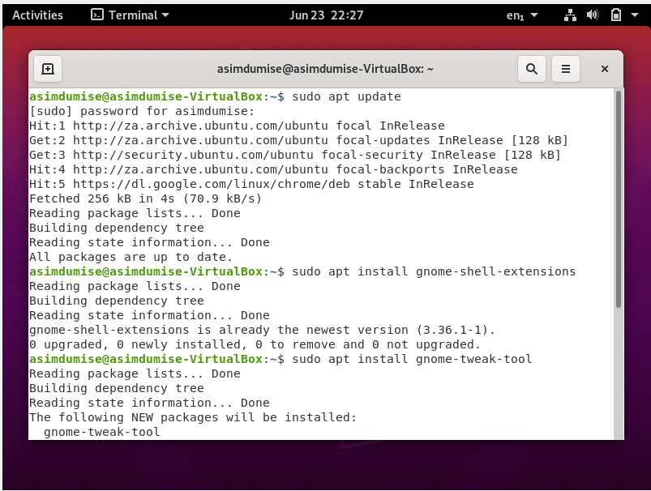

Figure 14 Installing GNOME shell extensions

After configuring, I therefore proceed to install dash to panel and clipboard indicator.

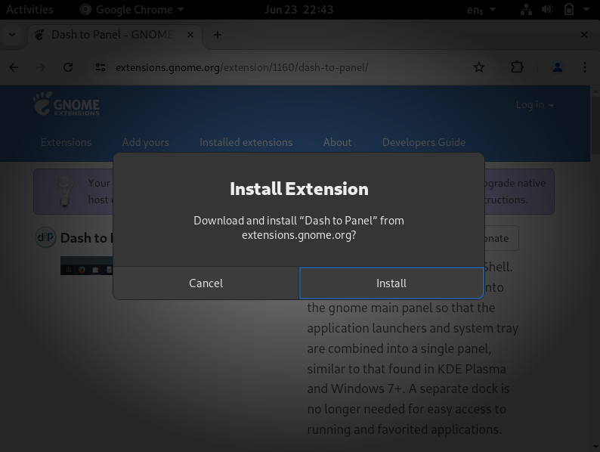

Figure 15 Installing Dash to Panel

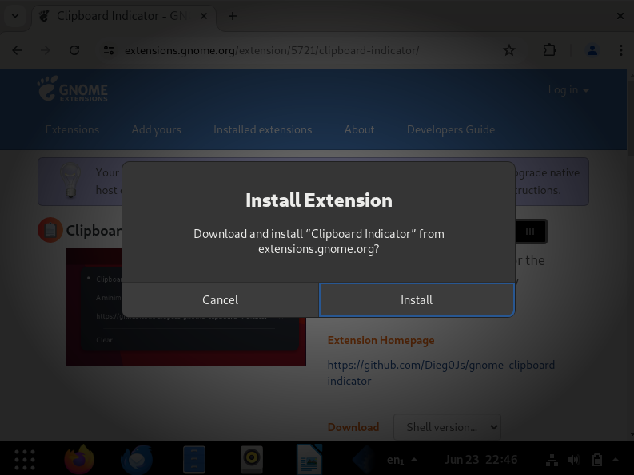

Figure 16 Installing Clipboard indicator

3.3. **Dash to panel:** Its purpose is to improve GNOME desktop usability by providing a taskbar-centric workflow, efficient window management, and customization choices for users switching from Windows, decreasing mouse movements and clicking.

Its function is to provide live previews of open windows, allowing for easy switching and selection. It includes system tray icons, which provide rapid access to settings and notifications. It also includes application grouping, activity indicators, and multi-monitor functionality.

* In order to install and configure it start by opening the GNOME Extensions website.
* Search for “Dash to panel”
* Turn it “ON” and then it will install
* Therefore configure it by adding applications and selecting workspaces.

**Clipboard indicator:** Its purpose is to improve clipboard management, increase productivity by giving quick access to previously copied objects, and to provide a simple interface for effective and intuitive clipboard management.

Its function is to allow users to access previously copied objects. It has search capabilities, persistent storage, customization choices, easy paste, data type support, keyboard shortcuts, and privacy settings.

* In order to install and configure it start by opening the GNOME Extensions website.
* Search for “Clipboard indicator”
* Turn it “ON” and then it will install
* Therefore configure it by adding applications and selecting workspaces.

3.4.1. Since I have already made this command: **sudo apt install gnome-tweak-tool.** I can discover several choices for personalizing my desktop experience inside the GNOME Tweak Tool settings.

3.4.2. In order for me to modify the theme, I launched GNOME Tweak Tool and navigated to the Appearance section. There were options to modify the shell, application, and cursor themes so I chose my preferred theme from the drop-down menu that was provided.

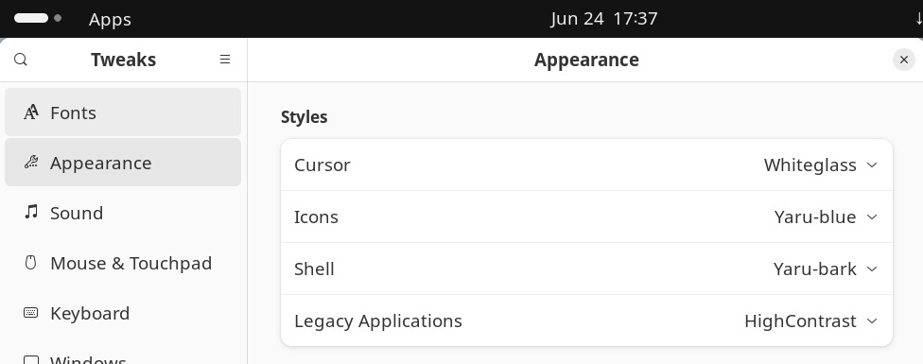

Figure 17 Appearance modification

3.4.3. This is how I created my personalized screensaver: I started by opening the GNOME Tweak Tool and I navigated to the “Extensions” area. I then pressed the “Screensaver Button”. I installed and enabled the extension. I selected and customized a screensaver of my choice by clicking on the screensaver icon in the top bar.

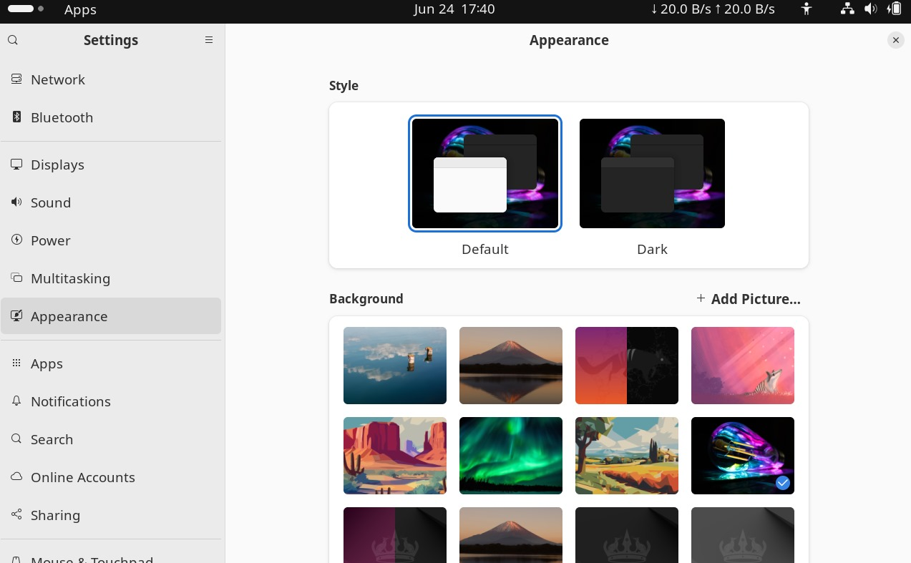

Figure 18 New screensaver

3.4.4. To improve readability, I adjusted the system typefaces and icon sizes. I launched GNOME Tweaks Tool and went to the “Fonts” area. I also modified the default icon style under the “Icons” section. I saved all my modifications after each customization step.

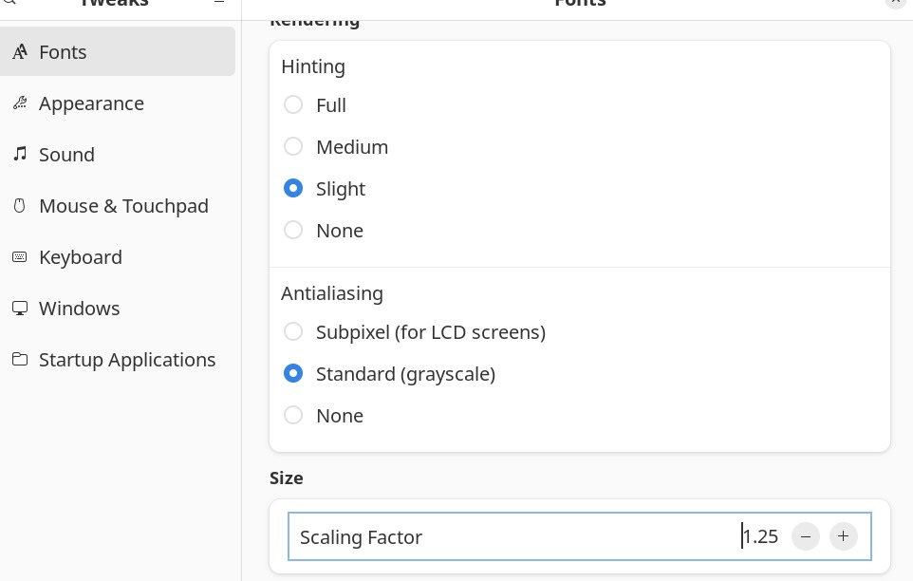

Figure 19 New font size

# Bibliography

Editor, S. (2024, March 4). *Simplilearn*. Retrieved from https://www.simplilearn.com

Fernando, T. (2024, February 27). *Linkedin*. Retrieved from https://www.linkedin.com

Hodgson, S. (2024, May 10). *StationX*. Retrieved from https://www.stationx.net

Qasim. (2023, August 31). *RedSwitches*. Retrieved from https://www.redswitches.com

Williams, J. (2018, October 18). *Ask Ubuntu*. Retrieved from https://askubuntu.com

Zandbergen, P. (2022, December 31). *Study.com*. Retrieved from https://study.com